VISVESVARAYA TECHNOLOGICAL UNIVERSITY
“JNANA SANGAMA”, Belagavi-590018


A Mini Project Report on
“FLIGHT BOOKING SYSTEM”

SUBMITTED IN PARTIAL FULFILLMENT OF THE REQUIREMENT FOR THE AWARD OF DEGREE OF

BACHELOR OF ENGINEERING IN INFORMATION SCIENCE AND ENGINEERING
SUBMITTED BY

MOHAN K (1JB23IS095)

Under the Guidance of
Mrs.Ranjitha J Assistant Professor, Dept. of ISE, SJBIT
Bengaluru-60

Department of information science and engineering

SJB Institute of Technology
BGS Health and Education city, Kengeri, Bengaluru-560060, Karnataka, India.

2024-2025

|| Jai Sri Gurudev ||
Sri Adichunchanagiri Shikshana Trust ®
SJB INSTITUTE OF TECHNOLOGY
BGS Health & Education City, Kengeri, Bengaluru – 560 060
Department of Information Science & Engineering


CERTIFICATE

Certified that the Mini project work entitled “FLIGHT TICKET BOOKING SYSTEM” carried out by MOHAN K bearing 1JB23IS095 is a bonafide student of SJB Institute of Technology in partial fulfilment for 5^{t} semester Mini Project in INFORMATION SCIENCE AND ENGINEERING of the VISVESVARAYA TECHNOLOGICAL UNIVERSITY, BELAGAVI during the academic year 2024-25. It is certified that all corrections/suggestions indicated for Internal Assessment have been incorporated in the report deposited in the departmental library. The mini project report has been approved as it satisfies the academic requirements in respect of Mini Project prescribed for the said degree.

Mrs.Ranjitha J Assistant Professor |  | Dr. Shashidhara HR Professor & Head
Dept. of ISE, SJBIT |  | Dept. of ISE, SJBIT
Name of the Examiners | EXTERNAL VIVA | Signature with Date
1.
2.




ACKNOWLEDGEMENT

We would like to express my profound thanks to His Divine Soul Padmabhushan Sri Sri Sri Dr. Balagangadharanatha MahaSwamiji and His Holiness Jagadguru Sri Sri Sri Dr. Nirmalanandanatha Swamiji for providing me an opportunity to pursue my academics in this esteemed institution.

We would also like to express my profound thanks to Revered Sri Sri Dr. Prakashnath Swamiji, Managing Director, SJB Institute of Technology, for his continuous support in providing amenities to carry out this mini project in this admired institution.

We express our gratitude to Dr. K. V. Mahendra Prashanth, Principal, SJB Institute of Technology, for providing excellent facilities and academic ambience, which have helped me in satisfactory completion of mini project work.

We extend our sincere thanks to Dr. Babu N V, Academic Dean, SJB Institute of Technology
for providing us constant support throughout the period of Mini Project.

We extend our sincere thanks to Dr. Shashidhara H.R, Professor & Head, Dept. of Information Science and Engineering, for providing us invaluable support throughout the period of Mini Project work.

We express our truthful thanks to our mini project co-ordinator, Dr. Siddanna S R, Assistant Professor, Dept. of Information Science and Engineering, who has been a source of inspiration to us and has extended his support throughout the mini project duration.

We express our truthful thanks to our guide, Mrs.Ranjitha J, Assistant Professor, Dept. of Information Science and Engineering, for providing us support throughout the mini project duration.

Finally, We take this opportunity to extend our earnest gratitude and respect to our parents, Teaching & Non-teaching staffs of the department, the library staff and all our friends, for their continuous support and encouragement.
MOHAN K (1JB23IS095)

TABLE OF CONTENTS

Sl. No. Chapters Page No.
Certificate 2
Acknowledgment 3
Table of Contents 4
Abstract 5
1. Introduction 6
1.1 Overview 6
1.2 Objectives 6
2. Software Requirements Specification 7
3. Hardware requirements 7
4. System Design 8
5. Implementation 9
6. Testing 10-16
Conclusion and Future Enhancements 17
References 18
List of Figures

Sl.No. Particular Page No.
Fig-1 Main function output 10
Fig-2 Book Ticket() 12
Fig-3 Cancel Ticket() 14
Fig-4 Search Ticket() 15
Fig-5 Check Availabity() 16

ABSTRACT

This program implements a flight ticket booking system that allows users to book, cancel, and search for flight tickets. It offers both domestic and international ticket options, each with different pricing. The system stores detailed information about each ticket, including passenger name, passport ID, source, destination, phone number, travel date, and airline. The program ensures that each passport ID can only be used for one booking at a time, preventing duplicate bookings. Users can view the availability of tickets for a specific destination and date. The system also enables users to cancel a ticket by providing a passport ID. Furthermore, it allows searching for a ticket based on passenger name and destination. The booking process includes selecting ticket types and entering passenger details. The program limits ticket bookings to a predefined maximum number. It provides a straightforward text-based interface, suitable for managing and organizing flight ticket reservations efficiently.

CHAPTER 1

INTRODUCTION

1.1 Overview of the Project

The provided C program implements a “Flight Ticket Booking System”that facilitates booking, searching, and managing flight tickets. Here's an overview of its key components and functionalities
1.2 Objectives
- Ticket Booking
-Ticket Cancellation
-Search For Ticket.
-Check Availability
-Display Ticket Details

CHAPTER 2

SOFTWARE REQUIREMENTS SPECIFICATION

Depending on the OS that you are using get a C compiler. If you are using Windows you can use Dev-CPP to begin with. You can also use Visual Studio Community. Visual Studio is a good IDE with support for many other programming languages.
On Linux you can use the gcc compiler to compile the files. It is easier to start with if you are using an IDE but it is not necessary. You can write the code in notepad or vim and compile them too. Bottom line is you need a compiler and a text editor.
We have used Ubuntu for our project. To compile and run a C program on the Ubuntu operating system via a file, we require the GCC compiler in our internal system. One of the build-essential packages that produces the various activities that we need to install from the Ubuntu repository is the GCC Compiler.
We can develop our C program in an Integrated Development Environment (IDE) like Visual Studio Code or a basic text editor which can compile and run all of the programs after installing the build-essential package.
This document defines the software requirements for the Flight Ticket Booking System, which enables users to book, cancel, search, and check availability for flight tickets. The system supports both domestic and international ticketing and ensures the management of all flight reservation details.

Hardware Requirements

Processor: A minimum of 1 GHz processor is required. A higher processing power (2 GHz or greater) is recommended for better performance.

Memory: At least 1 GB of RAM is needed for smooth operation. 4 GB of RAM or higher is recommended

Storage: A minimum of 100 MB of free disk space is required to store program files and libraries. 200 MB or more is recommended to ensure enough space for temporary files and logs.

CHAPTER 3

SYSTEM DESIGN

Includes flowcharts, ER diagrams, and a detailed architecture of the system.
Below is a basic flowchart showing how the system operates:

+-----------------------------------+
| Start the Program |
+------------------------------------+

+------------------------------------+
| Display Main Menu Options |
+------------------------------------+

+------------------------------------+
| Get User's Choice |
+------------------------------------+

+--------------------------------------------+ +-----------------------------------------+
| 1.BOOK TICKET | | Book a new ticket |
+--------------------------------------------+ +-----------------------------------------+

+--------------------------------------------+ +-----------------------------------------+
| 2.CANCEL TICKET | | Cancel Flight Tickets |
+--------------------------------------------+ +-----------------------------------------+

+---------------------------------------------+ +-----------------------------------------+
| 3.SEARCH TICKET | | Search Booked Tickets |
+---------------------------------------------+ +-----------------------------------------+

+---------------------------------------------+ +-----------------------------------------+
| 4.CHECK AVAILABILITY| | Check Your Tickets |
+---------------------------------------------+ +-----------------------------------------+

CHAPTER 4

IMPLEMENTATION

Details the logic and code used, including structures like structure array implemented in C.

1. Data Structures Used

- Array: the main data structure used is an array of Ticket structs, and this array holds all the flight tickets booked by passengers.
- Structures: Used to store passenger information such as name, passport id, phone number,travelling data,timing.

2. Core Functionalities

- Book Ticket(): Adds a new ticket to the tickets[] array if the booking limit is not reached.
- Cancel Ticket(): Marks a ticket as cancelled (sets is Booked to 0) based on the provided passport ID.
- Search Ticket(): Searches for a ticket by passenger name and destination.
- Check Availability(): Checks the availability of tickets by calculating the remaining capacity based on the ticket Count.
- Display Ticket Details(): Displays the details of a given ticket.
- Is Passport ID Booked(): Checks if a ticket with the given passport ID has already been booked.
- Find Ticket By Passenger And Destination(): Searches for a ticket by passenger name and destination.

CHAPTER 5

TESTING

Describes the testing scenarios, sample inputs, and results achieved.

Sample Outputs with program structure

a) Main function of the program
int main() {
int choice;

do {
printf("\n--- Flight Ticket Booking System ---\n");
printf("1. Book Ticket\n");
printf("2. Cancel Ticket\n");
printf("3. Search Ticket\n");
printf("4. Check Availability\n");
printf("5. Exit\n");
printf("Enter your choice: ");
scanf("%d", &choice);

switch (choice) {
case 1:
bookTicket();
break;
case 2:
cancelTicket();
break;
case 3:
searchTicket();
break;
case 4:
checkAvailability();
break;
case 5:
printf("Exiting the system. Thank you!\n");
break;
default:
printf("Invalid choice! Please try again.\n");
}
} while (choice != 5);
return 0;
}

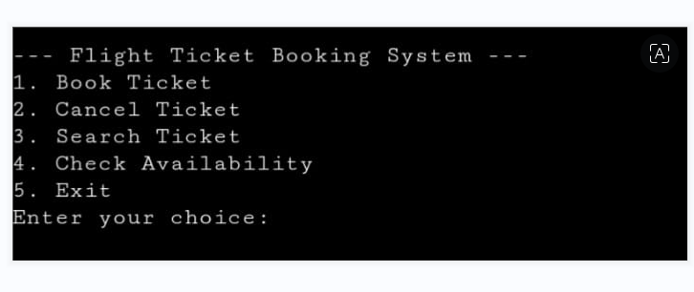
Figure 1

b) void bookTicket()
{
if (ticketCount >= MAX_TICKETS) {
printf("Ticket booking limit reached!\n");
return;
}
Ticket newTicket;
int ticketType;
printf("Select Ticket Type:\n");
printf("1. Domestic Ticket\n");
printf("2. International Ticket\n");
printf("Enter your choice: ");
scanf("%d", &ticketType);
newTicket.ticketPrice = (ticketType == 1) ? TICKET_PRICE_DOMESTIC : TICKET_PRICE_INTERNATIONAL;
strcpy(newTicket.airline, "Bharath Airlines");
strcpy(newTicket.timing, "7:00 PM(Departure)- 10:00 PM(Arrival)");
printf("Enter Passenger Name: ");
scanf("%s", newTicket.passengerName);
printf("Enter Passport ID: ");
scanf("%s", newTicket.passportID);
if (isPassportIDBooked(newTicket.passportID)) {
printf("Ticket is already booked for this Passport ID!\n");
int ticketIndex = findTicketByPassengerAndDestination(newTicket.passengerName, newTicket.destination);
if (ticketIndex != -1) {
displayTicketDetails(tickets[ticketIndex]);
}
return;
}

printf("Enter Source: ");
scanf("%s", newTicket.source);
printf("Enter Destination: ");
scanf("%s", newTicket.destination);
printf("Enter Phone Number: ");
scanf("%s", newTicket.phoneNumber);
printf("Enter Travel Date (dd-mm-yyyy): ");
scanf("%s", newTicket.travelDate);
newTicket.isBooked = 1;
tickets[ticketCount++] = newTicket;

printf("Ticket booked successfully!\n");
displayTicketDetails(newTicket);
}

Outputs

Fig-2 booking ticket
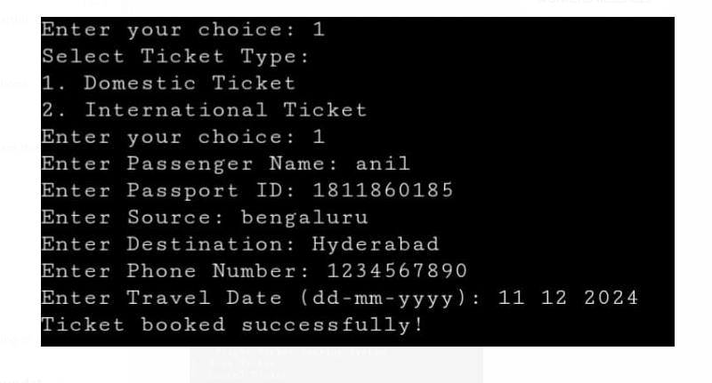
Figure 2

c) void cancelTicket()
{
char passportID[20];
printf("Enter Passport ID to cancel the ticket: ");
scanf("%s", passportID);

for (int i = 0; i < ticketCount; i++) {
if (strcmp(tickets[i].passportID, passportID) == 0) {
tickets[i].isBooked = 0; // Cancel ticket
printf("Ticket cancelled successfully!\n");
return;
}
}
printf("No ticket found with Passport ID: %s\n", passportID);
}

Output

Fig-3 cancelling ticket
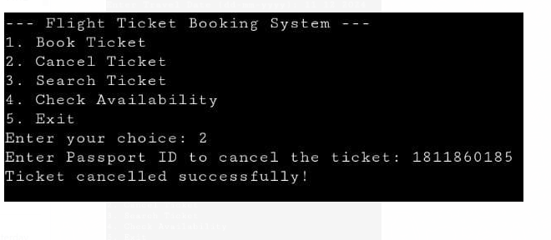

d) void searchTicket()
{
char name[50], destination[50];
printf("Enter Passenger Name: ");
scanf("%s", name);
printf("Enter Destination: ");
scanf("%s", destination);

int ticketIndex = findTicketByPassengerAndDestination(name, destination);
if (ticketIndex != -1) {
printf("Ticket is booked!\n");
displayTicketDetails(tickets[ticketIndex]);
} else {
printf("No ticket found for this passenger and destination.\n");
}
}

Output

Fig-4 search ticket
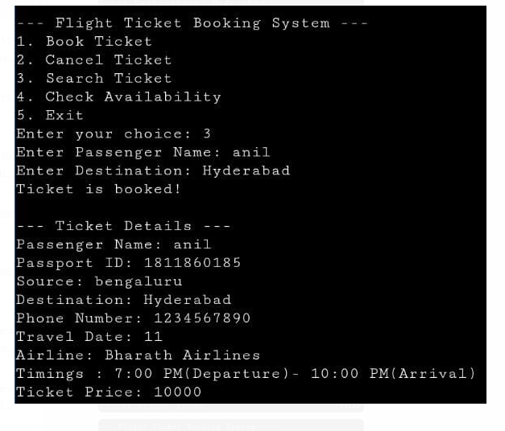

e)void checkAvailability()
{
char destination[50], travelDate[11];
printf("Enter Destination: ");
scanf("%s", destination);
printf("Enter Travel Date (dd-mm-yyyy): ");
scanf("%s", travelDate);

int availableTickets = MAX_TICKETS - ticketCount;
printf("Available tickets for %s on %s: %d\n", destination, travelDate, availableTickets);
}
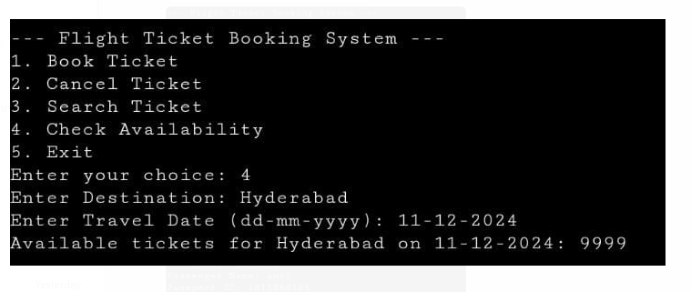

CONCLUSION AND FUTURE ENHANCEMENTS

Conclusion:
This code implements a flight ticket booking system, allowing passengers to book, cancel, search for tickets, and check availability based on destination and travel date. The system handles both domestic and international flights with different pricing, providing functions to manage a ticket database.
Overall, the program offers a basic flight ticket booking system with essential functionalities like booking, cancellation, searching, and availability checking. However, it lacks persistent storage (e.g., a database or file), so all data is lost when the program ends. Enhancements like user authentication and better error handling could improve the system further.
Future Enhancements:
- Add More Robust Input Validation
- Use Dynamic Memory Allocation for Tickets
- Enhance the Display of Ticket Information
- Add Support for Multiple Passengers per Booking
- Add Date Validation and Format Checking
- Track Booking History or Previous Bookings
- Implement Cancellation Confirmation
- Add Sorting Functionality for Booked Tickets

REFERENCES

[1] Fundamentals of Data Structures in C.
By: Ellis Horowitz and Sartaj Sahni
[2] An Introduction to Data Structures with Applications.
By: Jean-Paul Tremblay & Paul G. Sorenson
[3]http://elearning.vtu.ac.in/econtent/courses/video/CSE/06CS35.html.

